Room Choices

Nursery
http://www.bhg.com/bhg/decoratinggallery/room.jhtml?roomid=/templatedata/bhg/dg-room/data/N_whimsicaltouchesforbaby_12042003.xml

Kitchen
http://www.bhg.com/bhg/decoratinggallery/room.jhtml?roomid=/templatedata/bhg/dg-room/data/K_diykitchenmakeover_12052003.xml

Bathroom
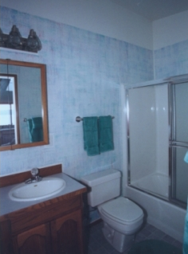

Living Room (if we do it)
http://www.bhg.com/bhg/decoratinggallery/room.jhtml?roomid=/templatedata/bhg/dg-room/data/LR_vibrantbutcozyliving_12072003.xml

